**SQL ASSIGNMENT-5**

Q1. Write a query to print details of workers excluding first names, “ Vipul” and “Satish” from Worker table.

**Solution:**

Step-1. Select * from worker where First_name !=’Vipul’ and First_name !=’Satish’

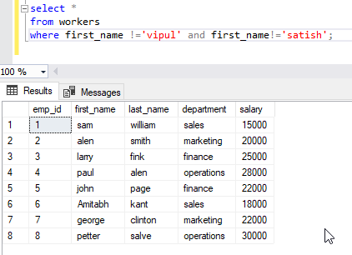

Q2. Write an SQL query to print details of workers whose FIRST_NAME ends with ‘h’ and contains six alphabets.

**Solution:**

Step-2. Select * from worker where First_name like ‘%h’ and LEN(First_name)=6;

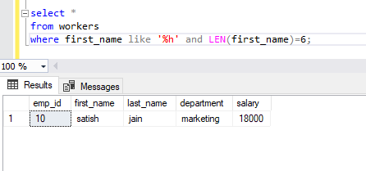

Q3. Write a query to validate Email of Employee.

**Solution:**

Step-3. Select * from worker where Email like ‘%_@_%’;

